**Business Scenario**

The Analytics team of an Online E-Commerce Company wants to design a Sales dashboard to analyze the sales based on various product categories. The company wants to add user control for product category, so users can select a category and can see the trend month-wise and product-wise accordingly.

The Analytics team also wants to create a histogram to analyze number of shipping days.

The company’s database keeps track of the following data fields:

Brand Name, Company Name, Disease Medical Use, Invoice date, Company code, Ship-to-Country, Ship-to-Country Full Name, Sold-to party- Code, Sold-to party Country, Sold-to party Country Full Name, Delivery Plant, Payment terms, External Agent, Sales quantity, Price TC /Kg, Revenue, External commissions, Month.

**Overview**

* Use the Saved Sample – E-Commerce database.
* Prepare a table of Sales and Profit month-wise in working sheet.
* Prepare the sales table region-wise in the working sheet.
* Create User Control Combo box for Product Category.
* Create Column Chart of month-wise table and region-wise table.
* Link the table with combo box.
* Create a dashboard.

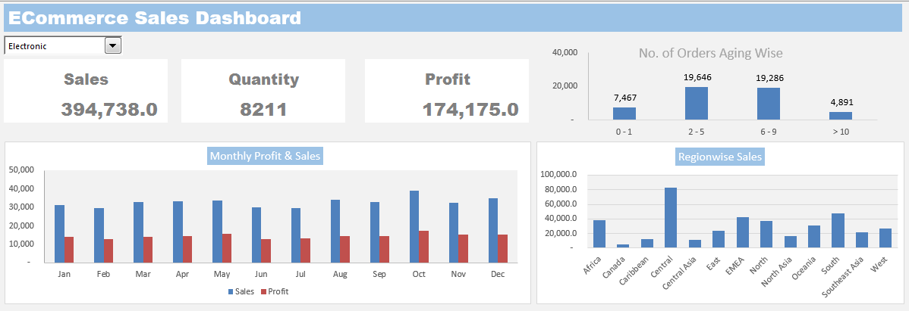

**Steps:**

**Step1: Create Histogram for Shipping Days(Aging)**

To create histogram, click the Data Tab, Under Analysis Group (Right Corner), Click Data Analysis.

Now, select Histogram and click ok. A histogram dialog box will appear.

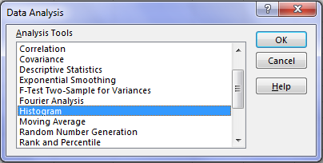

In the histogram dialog box, first click the Label’s Check box as we have labels in our data. After that, In the **Input reference box** select the range **(“Sales Data!D1:D51291”)** of our dataand in the **Bin Range Reference box** select **(“Working!K3:K7”)**.

In **Output section**, select range “Working!N3” for binning table, click Histogram check box and then ok.

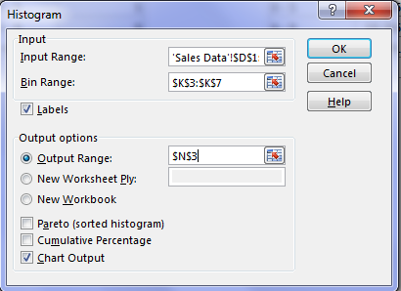

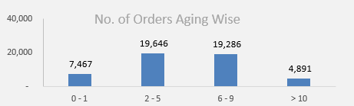

**Step2 - Create Combo Box:**

* Insert Combo box for product category list in the Dashboard Sheet.
* Click Developer Tab > Under Controls Panel > Click Combo box and draw.

Pass the Input Range and Cell for the Combo box.

* Right-click the country list Combo box > Click Format Control > Under Format Control Panel, Pass Input Range “Working!Q2:Q5” and Cell Link “Working!R2” from the working sheet.

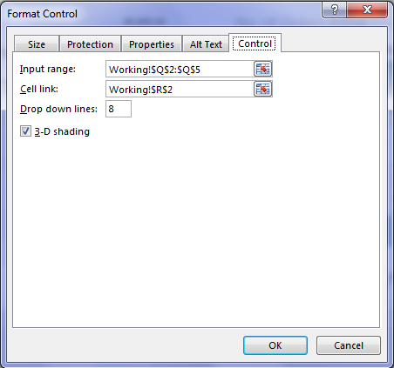

Now, write the offset function in cell “R3” to fetch the product category based on the selection in the product category Combo box.

* Write the equal sign and then the function name.
* Pass the first argument as Cell “$Q$1.”
* In the second argument, select the cell link cell “$R$2.”

**Step3: SUMIFS formula to calculate Total Sales, Quantity, and Profit**

Now, write Sumifs formula to calculate Sales, Quantity, and Profit in the Dashboard sheet.

Enter the formula in Cell C7:

* Enter the equal sign and then enter the function name and open parenthesis.
* Pass the first Argument is Sum_Range, select range ‘Sales Data’!$H:$H, and then enter comma.
* Now, pass the second argument Product Category column “criteria Range1” as ‘Sales Data’!$F:$F, enter comma
* Pass the third argument “criteria1” “Working!$R$3”, and enter comma.

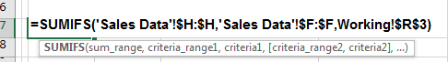

**Perform the same function to calculate the Quantity in Cell G7.**

* In G7, write the equal sign, and then enter the function name and open parenthesis.
* The first Argument is Sum_Range, select range ‘Sales Data’!I:I, and then enter comma.
* Now, pass the second argument Product Category column “criteria Range1” as ‘Sales Data’!F:F, and enter comma.
* Pass the third argument “criteria1” “$R$3,” and enter comma.

**For Profit**

* In K7, write the equal sign and then enter the function name and open parenthesis.
* The first Argument is Sum_Range, select range ‘Sales Data’!K:K, and then enter comma.
* Pass the second argument Product Category column “criteria Range1” as ‘Sales Data’!F:F, and enter comma.
* Now, pass the third argument “criteria1” “$R$3”, and enter comma.

**Step4: SUMIFS formula to calculate Sales and Profit month wise**

Now write the sumifs formula to calculate the Sales and profit month-wise and sales region-wise.

Enter formula in Cell C4:

* Enter the equal sign and then enter the function name and open parenthesis.
* The first Argument is Sum_Range, select range ‘Sales Data’!H:H, and then enter comma.
* Pass the second argument month column “criteria Range1” as ‘Sales Data’!U:U, and enter comma.
* Now, pass the third argument “criteria1” “$B$4,” and enter comma.
* Pass the fourth argument as Data!F:F product category column, and enter comma.
* Pass the fifth argument as “$R$3.”
* Now, copy and paste the formula in Range C4:C15.

Enter formula in Cell D4:

* Enter Equal sign then enters function name and open parenthesis
* The first Argument is Sum_Range, select range ‘Sales Data’!K:K, and then enter comma.
* Now, pass the second argument month column “criteria Range1” as ‘Sales Data’!U:U, and enter comma.
* Pass the third argument “criteria1” “$B$4,” and enter comma.
* Pass the fourth argument as Data!F:F product category column, and enter comma.
* Enter the fifth argument as “$R$3.”
* Now, copy and paste the formula in Range D4:D15.

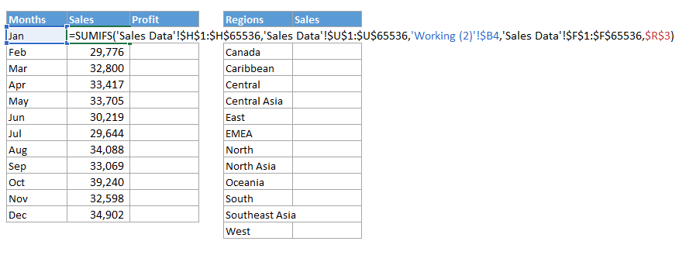

**Step5: SUMIFS formula to calculate Sales region wise**

* Write the equal sign and then enter the function name and open parenthesis.
* The first Argument is Sum_Rage, select range ‘Sales Data’!H:H, and then enter comma.
* Pass the second argument region column “criteria Range1” as ‘Sales Data’!T:T, and enter comma.
* Now, pass the third argument “criteria1” “$F$4,”and enter comma.
* Pass, the fourth argument as Data!F:F product category column, and enter comma.
* Pass the fifth argument as “$R$3.”
* Now, copy and paste the formula in Range G4:G15.

**Step 6: Create Column Chart**

Now, create the column chart for both region-wise and month-wise table.

Select table (B3:D15), click insert tab > under Charts Panel > Insert column chart.

Cut and Paste the chart in the Dashboard Sheet.

Perform the same steps for other tables to create chart.

Now, this is our sales Dashboard, we can apply any color in the interior of cells, and data series to format it.

Note: The dataset required for this project can be accessed from the “Download Center.”